How to Pay for Aftercare/Summer Camp using Broward County Public Schools Virtual E-Store

Step One:

Go to https://estore.browardschools.com

If you do not have an account, create one and continue the process.

Step Two:

Click on the person in the upper right corner and create/login to your Account. You will also need your child’s student number (06xxxxxxxx) to add to your profile

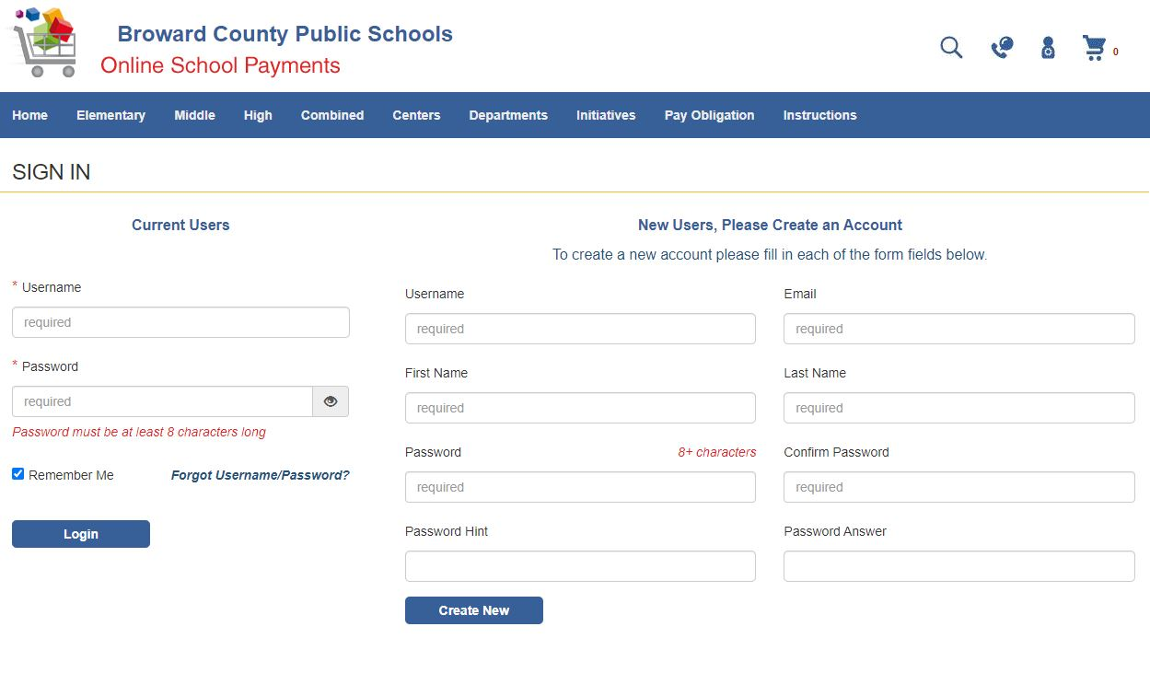

Step Three:

After you have logged in, click on ‘Elementary School’

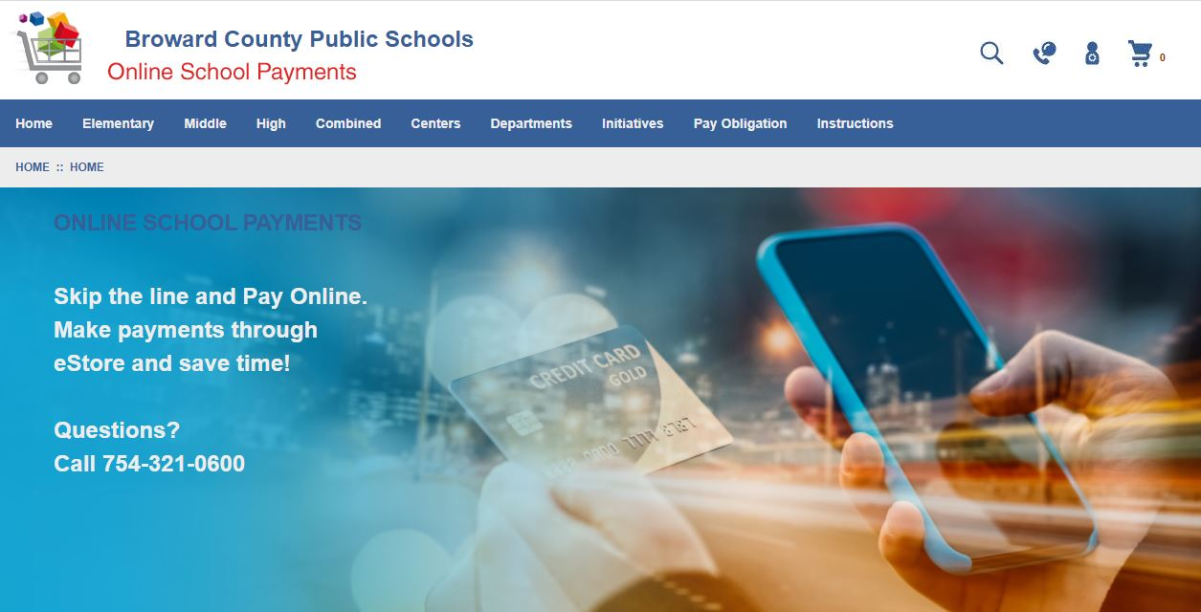

Step Four:

Scroll down and click on ‘Westchester Elementary’

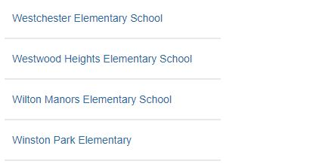

Step Five:

Click the appropriate items that relate to your child(ren). Remember all parents must include the $20 ACTIVITY FEE for all active child(ren) attending Camp each week.

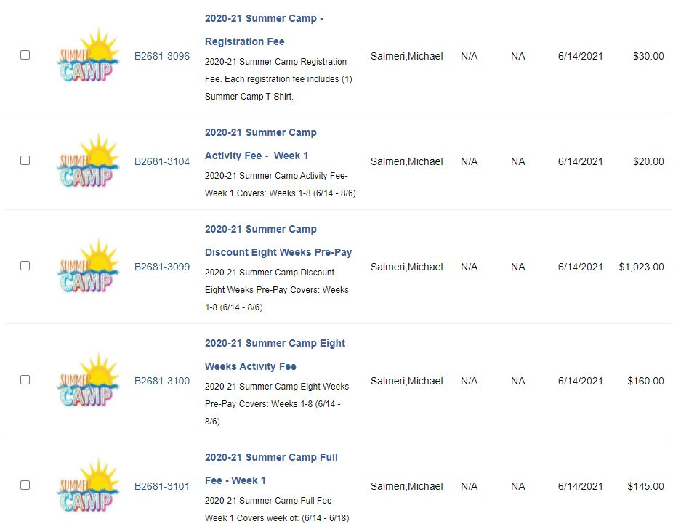

Step Six:

Review what items are in your cart and checkout. Do not hesitate to contact an Aftercare / Summer Camp Supervisor to review what you have placed into your Cart.

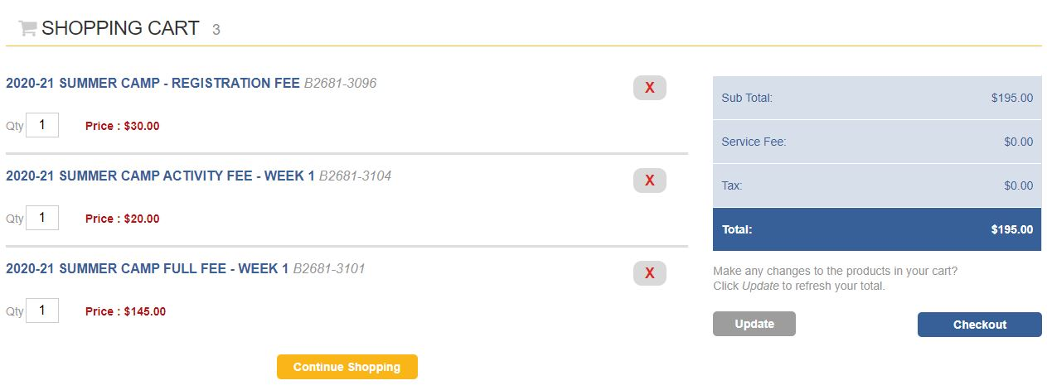
Step Seven:

Once you have checked out and paid you will receive a confirmation email with your purchases. Aftercare will also get a copy and note the purchase on our system.

If you have any questions please let me know,

Thank you

Email - Michael.salmeri@browardschools.com
Phone – 754-322-8928

